Project Design Phase
Problem – Solution Fit Template

Date | 09 september 2026
Team ID
Project Name | ServiceNow-Based Employee Laptop Request Application
Maximum Marks | 2 Marks

Problem – Solution Fit :
The Problem–Solution Fit for the ServiceNow-Based Employee Laptop Request Application identifies the difficulties employees and IT teams face in managing laptop requests. The proposed solution addresses these problems through a centralized ServiceNow platform that provides automated request submission, manager approval, IT fulfillment, real-time tracking, notifications, and asset management, resulting in a faster and more transparent laptop request process.
Purpose:
- Solve employee laptop request problems through a simple and centralized ServiceNow application.
- Improve solution adoption by providing an easy request, approval, and tracking process through the ServiceNow portal.
- Improve communication through automated notifications for request submission, approval, rejection, and fulfillment.
- Increase efficiency by reducing manual work, delays, repeated communication, and lack of request visibility.
- Understand employee and IT support needs to improve the laptop request and fulfillment process.
- Identify common request issues and provide a faster, transparent, and reliable solution for employees, managers, and IT teams.

Template: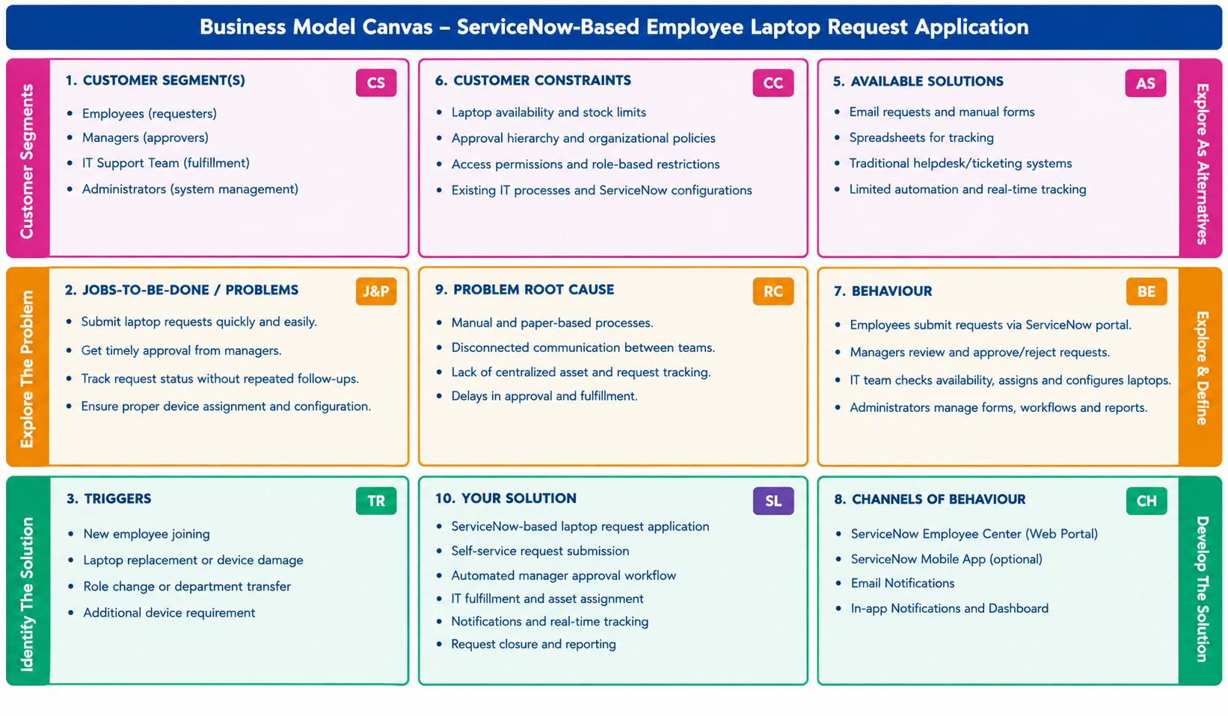

References:
1. https://mbejda.github.io/problem-solution-fit-canvas/?utm_source=chatgpt.com
2.https://mbejda.github.io/problem-solution-fit-canvas/?utm_source=chatgpt.com

